Graphene targets cancer stem cells
25 February 2015
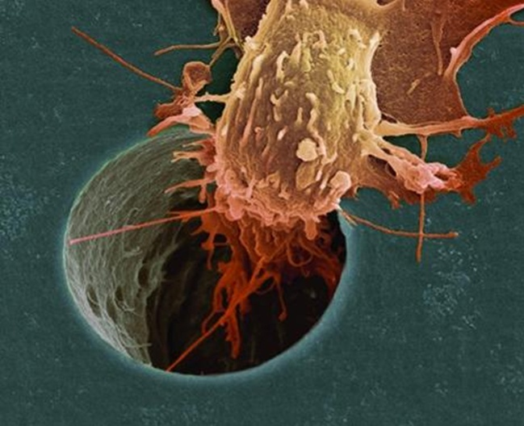
Scientists have used graphene to target and neutralise cancer stem cells while not harming other cells.
This new from development from Manchester University is claimed to open up the possibility of preventing or treating a broad range of cancers, using a non-toxic material.
Writing in Oncotarget, the team of researchers led by Prof Michael Lisanti and Dr Aravind Vijayaraghavan has shown that graphene oxide, a modified form of graphene, acts as an anti-cancer agent that selectively targets cancer stem cells (CSCs).
In combination with existing treatments, this could eventually lead to tumour shrinkage as well as preventing the spread of cancer and its recurrence after treatment. However, more pre-clinical studies and extensive clinical trials will be necessary to move this forward into the clinic to ensure patient benefit.
In a statement, Prof Lisanti, the director of the Manchester Centre for Cellular Metabolism within the University’s Institute of Cancer Sciences, said: ‘Cancer stem cells possess the ability to give rise to many different tumour cell types. They are responsible for the spread of cancer within the body - known as metastasis- which is responsible for 90 per cent of cancer deaths.
‘They also play a crucial role in the recurrence of tumours after treatment. This is because conventional radiation and chemotherapies only kill the ‘bulk’ cancer cells, but do not generally affect the CSCs.’
Dr Vijayaraghavan said: ‘Graphene oxide is stable in water and has shown potential in biomedical applications. It can readily enter or attach to the surface of cells, making it a candidate for targeted drug delivery. In this work, surprisingly, it’s the graphene oxide itself that has been shown to be an effective anti-cancer drug.
‘Cancer stem cells differentiate to form a small mass of cells known as a tumour-sphere. We saw that the graphene oxide flakes prevented CSCs from forming these, and instead forced them to differentiate into non-cancer stem-cells.
‘Naturally, any new discovery such as this needs to undergo extensive study and trials before emerging as a therapeutic. We hope that these exciting results in laboratory cell cultures can translate into an equally effective real-life option for cancer therapy.’
The team is said to have prepared a variety of graphene oxide formulations for testing against six different cancer types - breast, pancreatic, lung, brain, ovarian and prostate.
The flakes inhibited the formation of tumour sphere formation in all six types, suggesting that graphene oxide can be effective across all, or at least a large number of different cancers, by blocking processes which take place at the surface of the cells. The researchers suggest that, used in combination with conventional cancer treatments, this may deliver a better overall clinical outcome.
UK researchers are developing advanced graphene measurement techniques that could hasten the commercial applications of the revolutionary material.

Setting standards
27 January 2015 | By Ellie Zolfagharifard
UK researchers are developing advanced graphene measurement techniques that could hasten the commercial applications of the revolutionary material.
Graphene has been hailed as the ‘wonder material’ of the current generation. Despite being as thin as an atom, it is tougher than diamond and stronger than steel and can conduct electricity better than copper. Its impressive qualities could transform every aspect of our lives, from mobile phones that can be rolled up to medical devices that connect directly to neurons.
Since its discovery in Manchester a decade ago, almost 12,000 patents and patent applications have been filed for the material. Now, companies are beginning to put it to commercial use. Head NV last year introduced a graphene-infused tennis racket. Meanwhile, Apple, Saab and Lockheed Martin all have plans under way to develop graphene membranes and circuits in the near future.
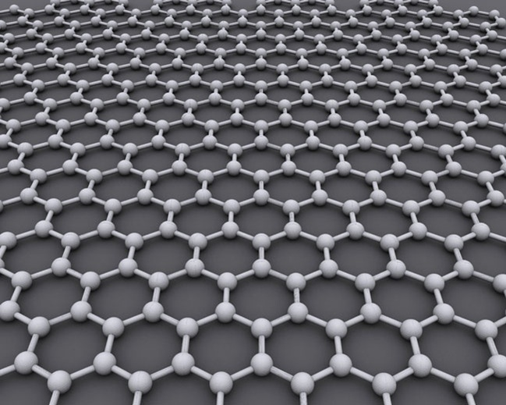Graphene is tougher than diamond and stronger than steel
But excitement for its applications has so far been tempered by a big flaw; there are no standards for the material. ‘Standards are particularly important for novel, revolutionary materials such as graphene,’ said Alexander Tzalenchuk, a National Physical Laboratory (NPL) fellow. ‘There is a lot of hype surrounding it and it is very easy to undermine confidence.’
For instance, a company may claim that a product has graphene in it, when it is in fact graphite. ‘The material may not be as strong as you would expect, or would not conduct heat or electricity as well, or would not hold as much electric charge,’ said Tzalenchuk. ‘Before any standard can be developed, we need to understand what kind of material we are dealing with and how it can be characterised.’
But characterisation has so far proved tricky. Graphene in its pristine form is just one layer of carbon atoms. This may sound simple, but its electronic, optical and mechanical properties are governed by complex quantum behaviour. As well as this, graphene’s characteristics are sensitive to the environment, making the measurement of its features particularly difficult.
In November, 20 scientists working on graphene at NPL signed an agreement with Manchester University to provide the measurement capability necessary to characterise graphene. ‘Currently we are working towards research projects where either a combination of existing methods or completely new online characterisation techniques could be developed as a result,’ said Manchester University research associate Antonios Oikonomou. Researchers already have a number of techniques to investigate graphene’s properties. One of the most common is Raman spectroscopy, in which a laser is used to shine onto the graphene and measure the reflected radiation. This radiation shifts in frequency and provides scientists with information about the material’s layers. Another technique is atomic force microscopy (AFM) in which a very sharp tip is scanned over graphene atoms.
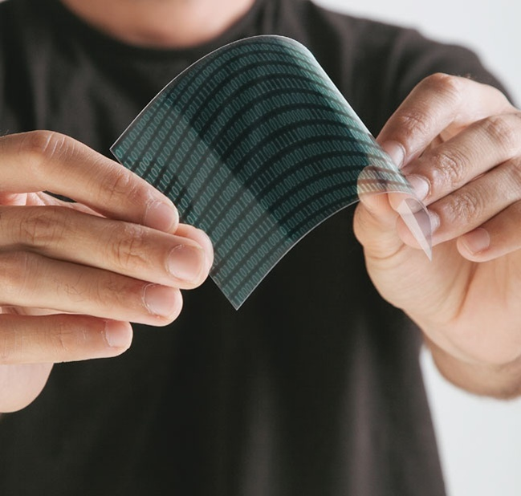Graphene’s potential uses include flexible plastic displays

‘All these techniques are now well understood; however, they all suffer one big downside: they are very impractical to use in a manufacturing environment for various reasons’, said JT Janssen, a principle research scientist at NPL. ‘With Raman and AFM, you can only investigate minute areas of the graphene — not much use for a 32in display.’ Instead, NPL is working on characterisation techniques that can be used in real time on large amounts of graphene.
One technique is a microwave measurement. Although graphene is transparent, it interacts strongly with microwaves, even though their wavelengths are 100,000 times longer than light. As a result, if a graphene film is placed in a microwave field, it will disturb the field. The extent of the disturbance is an indication of the sheet resistance and conductivity.
‘At present, these methods have been developed in a lab environment,’ said Janssen. ‘There will be challenges to integrate the measurement system in a production environment where there may be higher levels of noise, interference and environmental variations. Our existing system uses quite expensive instruments, but we are developing a much simpler and cheaper version that is more suited to the production line.’
According to Lux Research, sales of graphene will grow from £5.7m ($9m) in 2012 to £80m ($126m) in 2020. If the UK gets the standards right, it could gain a large slice of the market. For now, it seems the government is providing its backing. In March’s budget, chancellor George Osborne pledged investment in graphene, describing it as a ‘great British discovery that we should break the habit of a lifetime with and commercially develop in Britain’.
Oikonomou believes the real benefits of graphene will be in its use for ‘green’ technologies, such as membranes, lightweight composites and batteries. ‘I strongly believe that a combination of the material’s unique properties with innovative application design driven by social needs could lead to useful products and processes,’ he explained. ‘It is the need to solve a problem that leads to disruptive and innovative technologies, and there are no larger needs than the ones that we face on a global level.’

The process of developing standards for graphene
There are a number of committees that have to agree on proposed standards for graphene. For example, the committee of International Standards Organisation (ISO) for nanotechnologies, TC 229, has 34 participating and 14 observing countries. Another committee, the International Electrotechnical Commission (IEC), which mainly focuses on electrical and electronic products, has 14 participating and 18 observing.
Each committee has working groups that deal with issues such as terminology, measurement and characterisation, health and safety and material specs. ‘Trust me: only to have everyone in a room to agree for the terminology and nomenclature of graphene takes lots of effort,’ said Manchester University’s Antonios Oikonomou.
‘Fortunately, there are already under development standards related to graphene, such as the ISO/NP TR 19733, named as “Matrix of characterisation and measurement methods for graphene”, or the IEC 62607-6-2, which deals with the evaluation of the number of layers of graphene. The only thing I can wish for is effective communication between the interested parties, which will speed up the standardisation process.’

Graphene Demonstrates Anticancer Activity
Feb 25, 2015
- Scientists at the University of Manchester say they have used graphene to target and neutralizecancer stem cells while not harming other cells. This new development opens up the possibility of preventing or treating a broad range of cancers, using a non-toxic material, according to the researchers.
In a study (“Graphene oxide selectively targets cancer stem cells, across multiple tumor types: Implications for non-toxic cancer treatment, via differentiation-based nano-therapy”) in Oncotarget, the team led by Professor Michael Lisanti, M.D., Ph.D., and Aravind Vijayaraghavan, Ph.D., reported that graphene oxide, a modified form of graphene, acts as an anticancer agent that selectively targets cancer stem cells (CSCs). In combination with existing treatments, this could eventually lead to tumor shrinkage as well as prevent the spread of cancer and its recurrence after treatment, noted Dr. Lisanti. However, more preclinical studies and extensive clinical trials will be necessary to move this forward into the clinic to ensure patient benefit.
"Cancer stem cells possess the ability to give rise to many different tumour cell types,” explained Dr. Lisanti, director of the Manchester Center for Cellular Metabolism within the university’s Institute of Cancer Sciences. “They are responsible for the spread of cancer within the body, which is responsible for 90% of cancer deaths. They also play a crucial role in the recurrence of tumors after treatment. This is because conventional radiation and chemotherapies only kill the 'bulk' cancer cells, but do not generally affect the CSCs."
“Graphene oxide is stable in water and has shown potential in biomedical applications,” added Dr. Vijayaraghavan. It can readily enter or attach to the surface of cells, making it a candidate for targeted drug delivery. In this work, surprisingly, it's the graphene oxide itself that has been shown to be an effective anticancer drug.
"Cancer stem cells differentiate to form a small mass of cells known as a tumour-sphere,” continued Dr. Vijayaraghavan. “We saw that the graphene oxide flakes prevented CSCs from forming these, and instead forced them to differentiate into non-cancer stem cells.
"Naturally, any new discovery such as this needs to undergo extensive study and trials before emerging as a therapeutic. We hope that these exciting results in laboratory cell cultures can translate into an equally effective real-life option for cancer therapy."
The team prepared a variety of graphene oxide formulations for testing against six different cancer types (breast, pancreatic, lung, brain, ovarian, and prostate). The flakes inhibited the formation of tumor sphere formation in all six types, suggesting that graphene oxide can be effective across all, or at least a large number of different cancers, by blocking processes which take place at the surface of the cells.
“Mechanistically, we present evidence that GO exerts its striking effects on CSCs by inhibiting several key signal transduction pathways (WNT, Notch and STAT-signaling) and thereby inducing CSC differentiation,” wrote the investigators. “Thus, graphene oxide may be an effective non-toxic therapeutic strategy for the eradication of cancer stem cells, via differentiation-based nano-therapy.”
The researchers suggest that, used in combination with conventional cancer treatments, this approach may deliver a better overall clinical outcome.

